|  |  |
| --- | --- |
| **Name:- Aryan Dilipbhai Langhanoja** | **Roll Number:- 92200133030** |
| **Subject Name and Code:-** Foundation Skills On Sensor Interfacing (01CT1103) | **Date of Experiment:- 18-11-2022** |

|  |  |
| --- | --- |
| Task:- |  |

Interface Potentiometer and Turn on the LED if the value is beyond threshold.

|  |  |
| --- | --- |
| Components: |  |

* Arduino Uno R3
* LED
* Jumper Wires (Male To Male)
* Bread Board
* Potentiometer
* Laptop Or PC

|  |  |
| --- | --- |
| About the Project:- |  |

* In thisproject, we are going to use Arduino to blink the LED by the potentiometer. In this Project, We will connect One Resistor with Digital Pin 3 of Arduino and Connect Other Terminal of Resistor with Anode of LED. And Cathode Is Connected With Ground. After That We Will Program the Arduino in Such a Way That Whatever output potentiometer gives, The LED Blinks as respectively.

|  |  |
| --- | --- |
| Output(you circuit implementation):- |  |

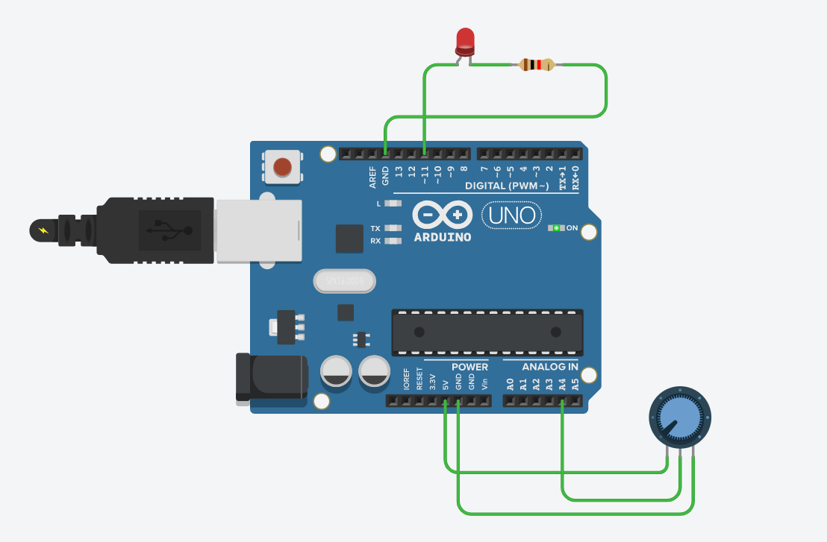

|  |  |  |
| --- | --- | --- |
| Schematic:- |  |  |

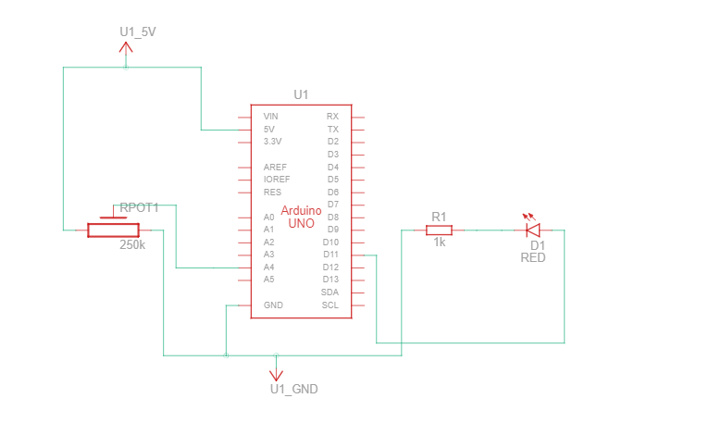



|  |  |
| --- | --- |
| Code:- |  |

|  |  |
| --- | --- |
| Conclusion:- |  |

* In this project, we learnt that how to blink LED with the help of Potentiometer.